|  |  |  |
| --- | --- | --- |
|  | **BAHRIA UNIVERSITY, (Karachi Campus)**  *Department of Software Engineering*  **Open Ended Lab -1**  **Semester Fall 2020** |  |

**Course Title:**  Computer Programming **Course Code**:

**Course Instructor:** Engr. Adnan ur Rehman **Class**: BSE-1(B)

**Lab Instructor:** Engr. Ramsha Mashood **Name: M Muaz Shahzad**

**Max. Marks:** 30 Marks **Reg no: 02-131202-081**

**Time:**  3 hours **Date:** 19-11-2020

**NOTE:**

* Plagiarism is not allowed, if found you will get zero marks.
* Try to submit the task on LMS in given Time.
* Include your name or enrollment no on footer.
* Your File name should be in the given format:
  + [**BSE 1 B**] [**M Muaz Shahzad**] DSAOEL1

**(BSE-1B) M Muaz Shahzad DSAOEL1**

**TASK # 01:** Create a simple C# Application to implement any real world problem using nested loop (**Marks: 10)**  
  
**Solution**namespace midz_task_1

{

class Program

{

static void Main(string[] args)

{

Console.WriteLine("Name: M Muaz Shahzad ");

Console.WriteLine("Reg: 02-131202-081 ");

int i = 0;

while (i < 6)

{

int j = 0;

while (j < 6)

{

Console.Write("({0},{1}) ", i, j);

j++;

}

i++;

Console.WriteLine();

Console.ReadLine();

}

}

}

}

**Output:**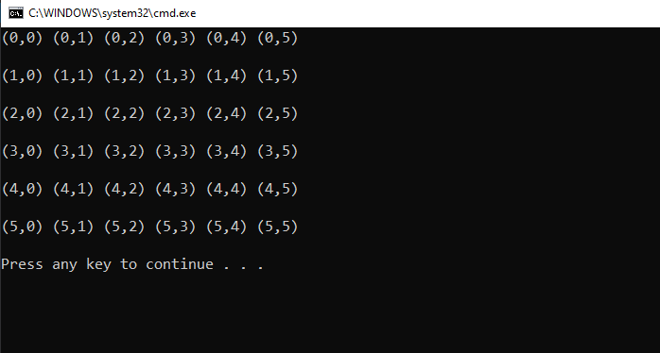

**TASK # 02:** Create a simple c# application to reverse any number given by user. Use any c# method to implement that task. **(Marks: 10)**  
**Solution:**

namespace Midz_task_2

{

class Program

{

static void Main(string[] args)

{

int j, k, reverse, sum = 0;

Console.Write("\nEnter Numbers: ");

j = Convert.ToInt32(Console.ReadLine());

for (k = j; k != 0; k = k / 10)

{

reverse = k % 10;

sum = sum * 10 + reverse;

}

Console.WriteLine("\nReverse Order Of Numbers: {0} ", sum);

Console.ReadKey();

//for loop I understand this well so that’s I did it

}

}

}

**Output:**

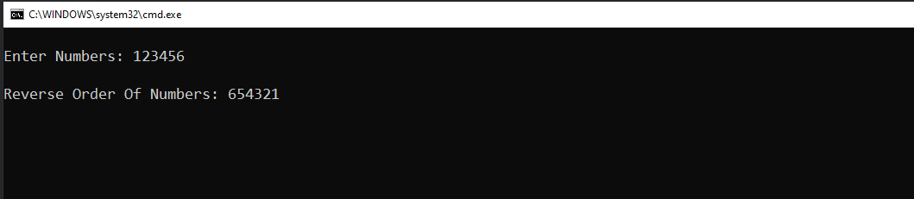

**TASK # 03:** The distance between two cities (in km) as input from user. Write a Program to print the distance in any of the following unit according to user requirements: **(Marks: 10)**

* 1 kilometer = 1000 meters
* 1 kilometer = 3280.8399 feet
* 1 kilometer = 39370.0787 inch

1 kilometer = 100000  
  
**Solution:**namespace Cp_Midz

{

class Program

{

static void Main(string[] args)

{

Console.Write("\nENTER YOUR STARTING POINT: ");

string x, y;

x = Console.ReadLine();

Console.Write("\nCHOOSE DESTINATION: ");

y = Console.ReadLine();

Console.Write("\nTotal Distance In Km: ");

double c;

c = Convert.ToDouble(Console.ReadLine());

Console.WriteLine("========================");

Console.WriteLine("Conversion Of Distance");

Console.WriteLine("1.Distance in Feets");

Console.WriteLine("2.Distance in Meters");

Console.WriteLine("3.Distance in Centimeters");

Console.WriteLine("4.Distance in Inches");

Console.WriteLine("=========================");

Console.WriteLine("\nChoose Num Between 1 to 4");

int d;

d = Convert.ToInt32(Console.ReadLine());

if(d == 1)

{

Console.WriteLine("\n========================");

Console.WriteLine("In Feets: " + c * 3280.8399);

Console.WriteLine("==========================");

Console.ReadKey();

if (d == 2)

{

Console.WriteLine("\n====================");

Console.WriteLine("In Meters: " + c * 1000);

Console.WriteLine("======================");

Console.ReadKey();

}

else if (d == 3)

{

Console.WriteLine("\n===========================");

Console.WriteLine("In Centimeters: " + c * 100000);

Console.WriteLine("=============================");

Console.ReadKey();

}

}

else

{

Console.WriteLine("\n==========================");

Console.WriteLine("In Inches: " + c * 39370.0787);

Console.WriteLine("============================");

Console.ReadKey();

}

}

}

**Output:**

